|  |  |
| --- | --- |
|  | **School of Engineering**  **COURSEWORK SUBMISSION SHEET** |
|  |
| All sections except the “LATE DATE” section must be completed and the declaration signed, for the submission to be accepted. All coursework should be submitted to turnitin through Campus Moodle.  **EXTENSIONS** –all requests for extensions must be submitted on the [Coursework Extension form](http://www.rgu.ac.uk/about/academic-affairs/quality-assurance-and-regulations/academic-regulations-student-forms), prior to the due date.  **LATE COURSEWORK** – coursework received late and without valid reason will be recorded as a Non-Submission (NS) and will be considered as one assessment opportunity. If applicable, a late submission should be submitted with an [Extenuating Circumstances](http://www.rgu.ac.uk/about/academic-affairs/quality-assurance-and-regulations/academic-regulations-student-forms) Claim Form and the related supporting evidence. | |

|  |  |
| --- | --- |
| **Due Date** | **For official use only** |
| 22/12/2015 |  |

|  |  |
| --- | --- |
| **MATRIC No** | **1507085** |
| **SURNAME** | ONUMAH |
| **FIRST NAME(S)** | EMMANUEL KWESI |
| **COURSE TITLE** | **MSc IT for the Oil & Gas Industry** |
| **MODULE NUMBER** | **ENM500** |
| **MODULE TITLE** | **Petroleum Geoscience** |
| **ASSIGNMENT TITLE** | **Part B – Well Log Interpretation Exercise** |
| **LECTURER ISSUING COURSEWORK** | **Gbenga Oluyemi** |

|  |
| --- |
| I confirm: (a) the inclusion of my signature below (electronic or otherwise) certifies that the work undertaken for this assignment is entirely my own and that I have not made use of any unauthorised assistance.*  (b) that the sources of all reference material have been properly acknowledged.*  (c) that I accept that the School will dispose of uncollected coursework at the end of term via the paper recycling service.  (d) that I will retain a copy of all coursework until the end of my studies.  **\* For information on Academic Misconduct, refer to** [**http://www.rgu.ac.uk/about/academic-affairs/quality-assurance-and-regulations/academic-regulations-student-forms**](http://www.rgu.ac.uk/about/academic-affairs/quality-assurance-and-regulations/academic-regulations-student-forms)**]** |

|  |  |  |  |
| --- | --- | --- | --- |
| **Signed** | *EMMANUEL KWESI ONUMAH* | **Date** | 22/12/2015 |

|  |  |
| --- | --- |
| Marker’s Comments | |
| Marker | Grade |

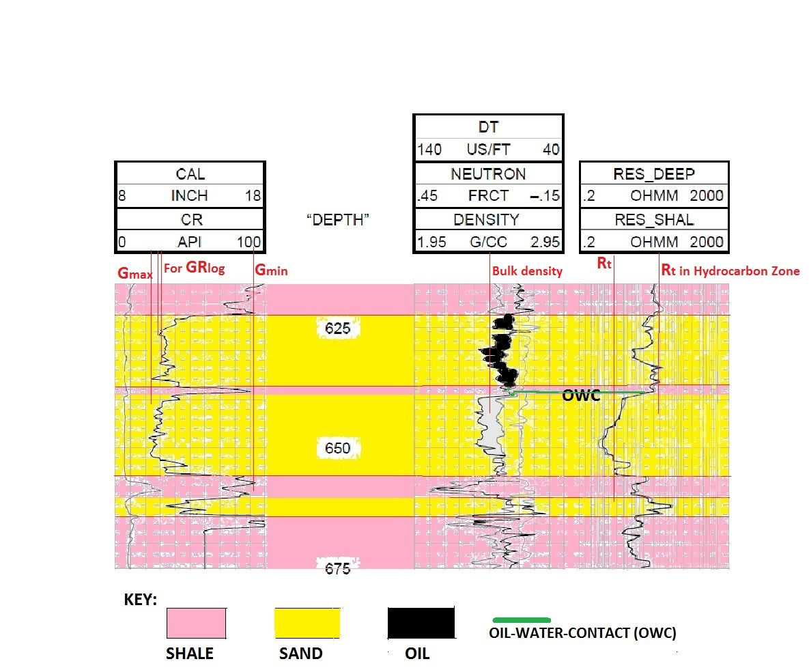

(a) (i) From the Log above, Gamma radiations of interest is in the Zone/depth 622m-638m because Resistivity is high.

Therefore GRlog  = = 26.67

GRmax = 94 API and GRmin = 22 API

IGR = = = = 0.065

Where IGR = Gamma ray Index, GRlog = Gamma reading of formation from log

GRmax = Maximum gamma ray (from sand) GRmin = Minimum gamma ray (from shale)

The North Sea well is Assume to have older rocks, Therefore The

Volume of shale (Vsh) = 0.33*(22*IGR – 1.0)

Vsh = 0.33 * (22*0.065 – 1.0) = 0.33*(1.094-1.0)

Vsh = 0.33 (0.094) = 0.0066

Therefore the volume of Shale (Vsh) = 0.031 = 3.1%

(ii) The position of the Oil-Water-Contact is indicated in the above diagram.

(iii) Porosity (Ø) = $\frac{ρma- ρb}{ρma- ρfluid}$

Where ma = grain density = 2.66 g/ cm3, fluid = 1.0 g/cm3

From the log, b = 2.45 g/cc

Ø = $\frac{2.66-2.45}{2.66-1.0}$ = $\frac{0.21}{1.66}$ = 0.127

Ø = 12.7%

(iv) From Archie Equation Sw= $\sqrt{\frac{a*Rw }{Ø^{m}*Rt}}$

Where:

Sw = water saturation, Rw = Resistivity of water (ohm)

Rt = True resistivity (ohm), a = tortuosity factor

Since It is 100% Water (Sw) = 1, From the Log, Rt from the water zone = 0.9, a = 1 and m = n = 2

Rw = Ø2 Rt Rw = (0.127)2 (0.9)

Rw = 0.013

Sw =

From the Log, True resistivity (Rt) from the hydrocarbon zone = 10

Therefore, Sw = =

Hence, Sw = 0.30 = 30%

(b) An Algorithm is written in Java to compute for the above parameters.